Open Two-Segment Polygonal Shape
# Source: AI Source: Provided by: [Data Path: Persons Table -> ID Column: 1, Name_En Column: Motasem Essam] -> From: [ChatGPT] on [7/25/2026]
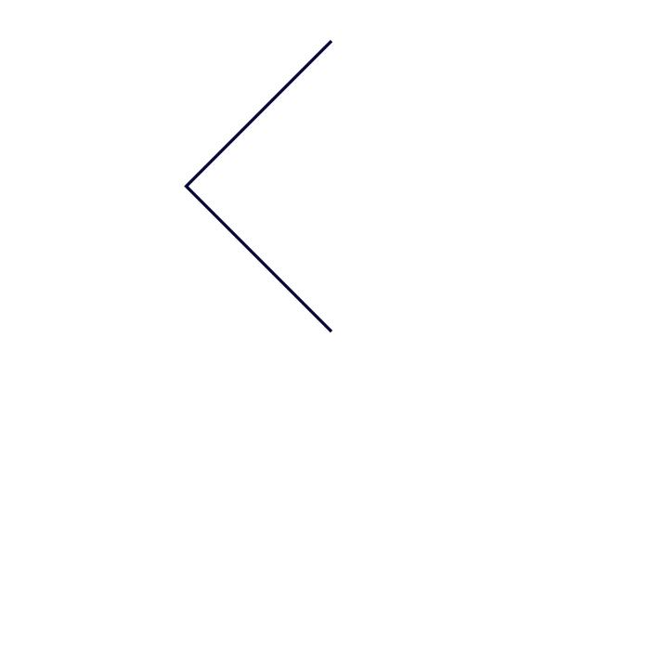
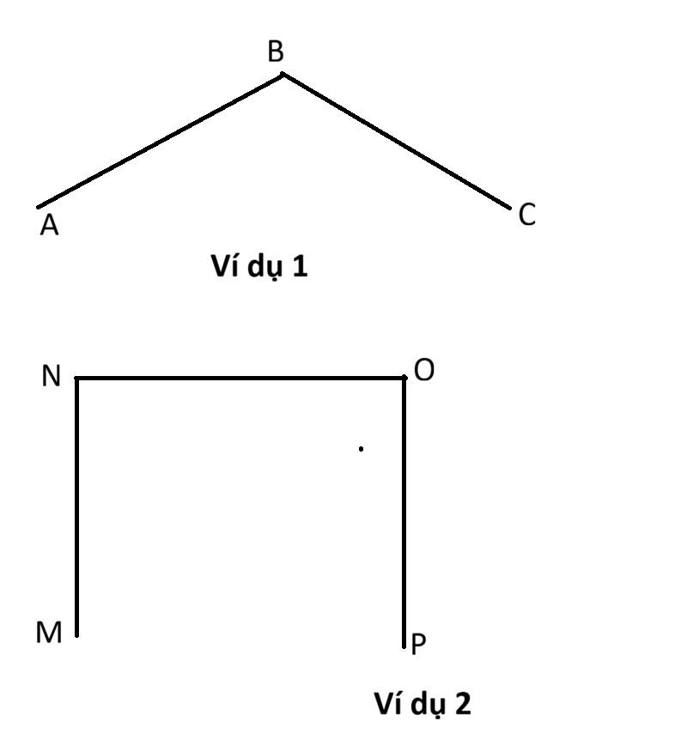
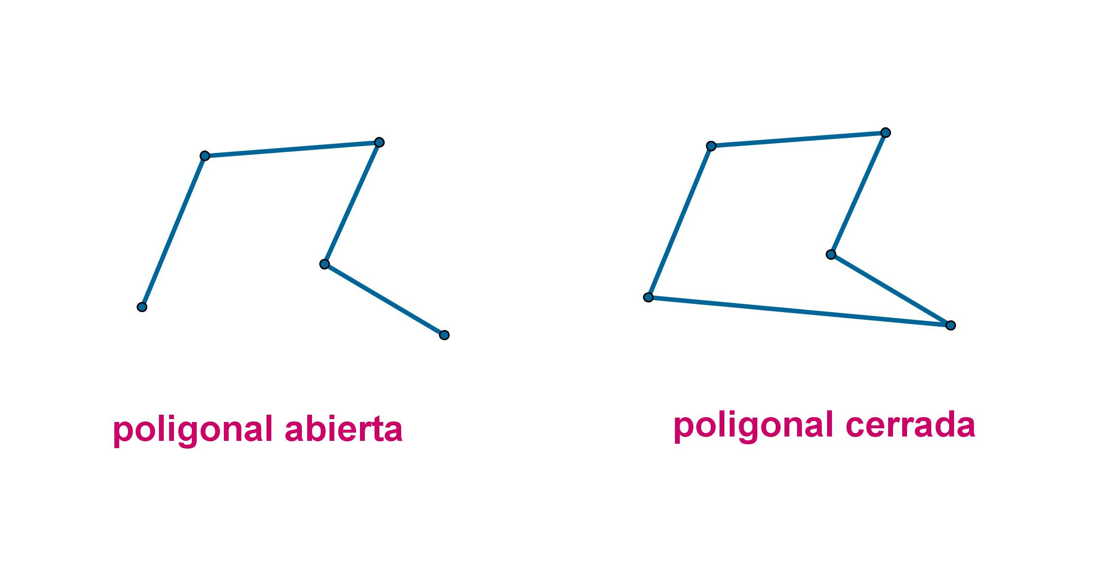

Definition
# Source: AI Source: Provided by: [Data Path: Persons Table -> ID Column: 1, Name_En Column: Motasem Essam] -> From: [ChatGPT] on [7/25/2026]
An Open Two-Segment Polygonal Shape is an open geometric figure formed by exactly two straight line segments connected at a common endpoint.
$$\boxed{\text{Open Two-Segment Polygonal Shape}2\text{ Straight Segments}+1\text{ Common Vertex}+\text{Open Boundary}}$$
It does not enclose a region because its endpoints do not connect.

Characteristics
# Source: AI Source: Provided by: [Data Path: Persons Table -> ID Column: 1, Name_En Column: Motasem Essam] -> From: [ChatGPT] on [7/25/2026]
An Open Two-Segment Polygonal Shape:
- Has exactly 2 straight line segments.
- Has 1 shared endpoint, forming a vertex.
- Has 2 unconnected endpoints.
- Is open.
- Does not enclose an area.
- Has a polygonal/straight-line boundary.
- Can form different angles at the common vertex.
- Can be straight, bent, acute, right, or obtuse depending on the angle.

Types

1. Open V-Shaped Two-Segment Shape
# Source: AI Source: Provided by: [Data Path: Persons Table -> ID Column: 1, Name_En Column: Motasem Essam] -> From: [ChatGPT] on [7/25/2026]
Two segments meet at a vertex and form a visible V-like shape.
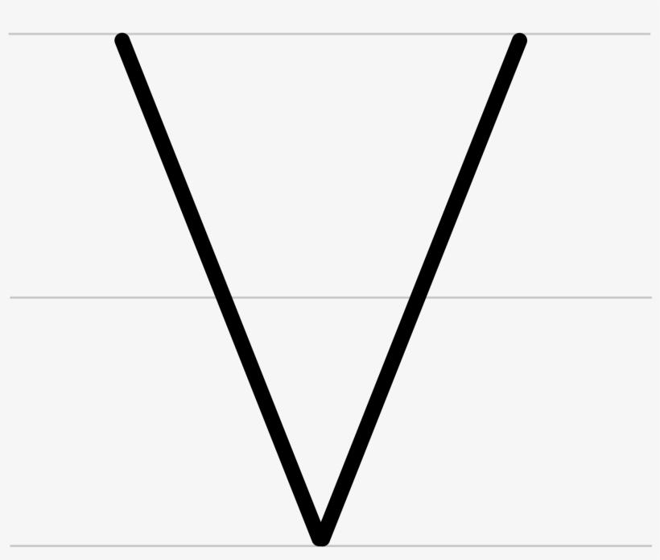
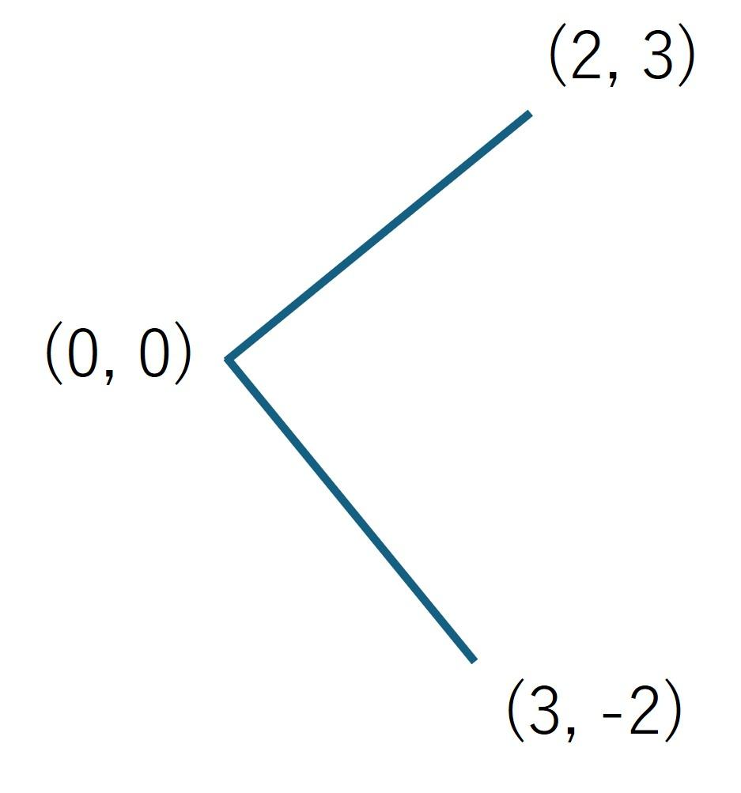
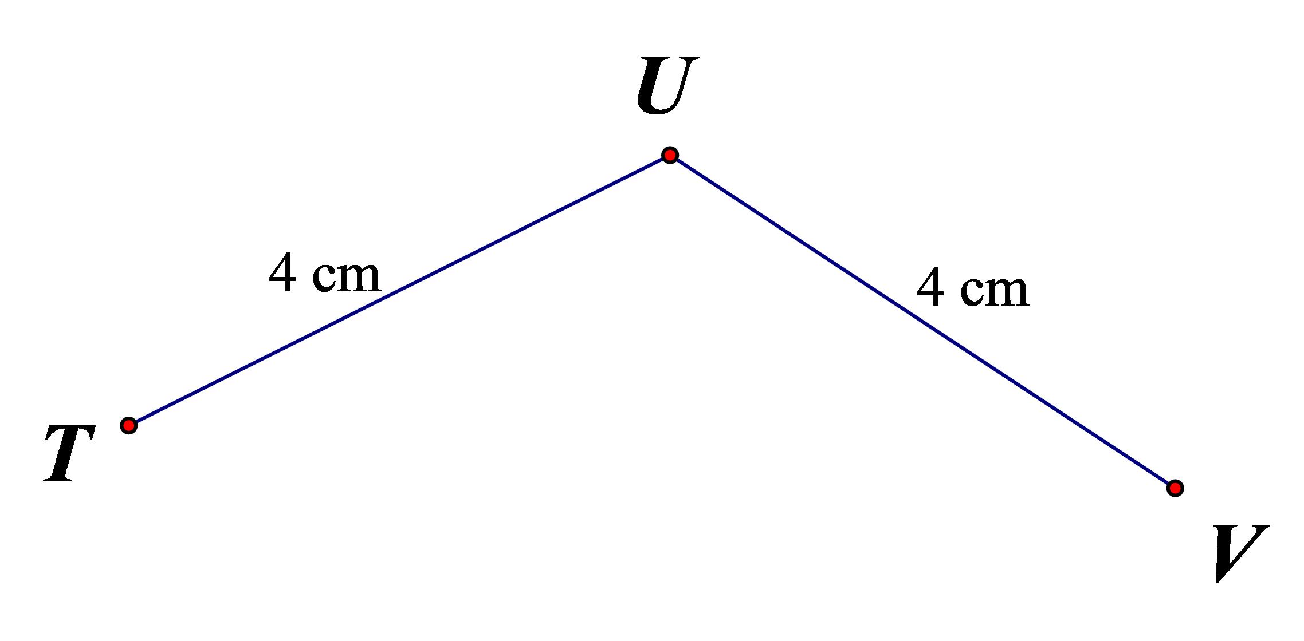
The two segments are not connected at their outer endpoints.

2. Open L-Shaped Two-Segment Shape
# Source: AI Source: Provided by: [Data Path: Persons Table -> ID Column: 1, Name_En Column: Motasem Essam] -> From: [ChatGPT] on [7/25/2026]
Two perpendicular segments meet at a (90^\circ) angle.
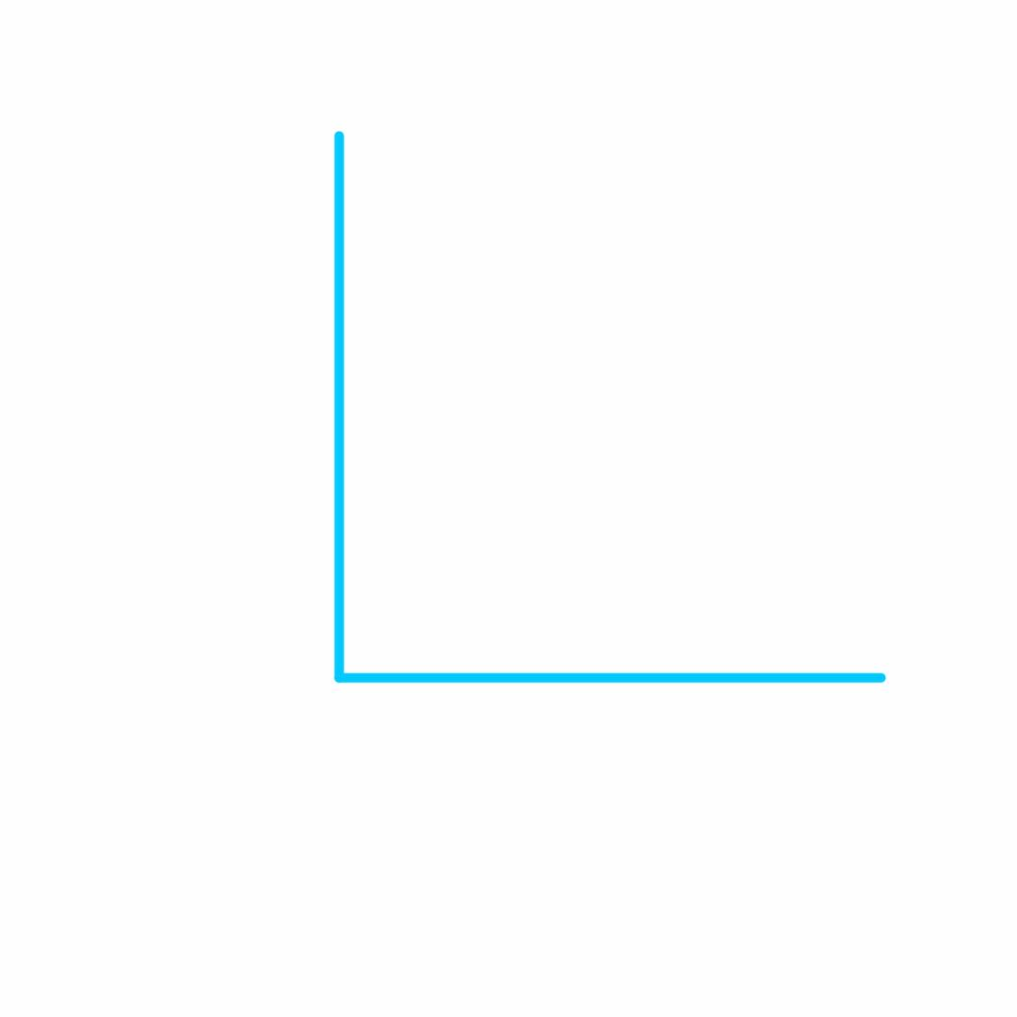
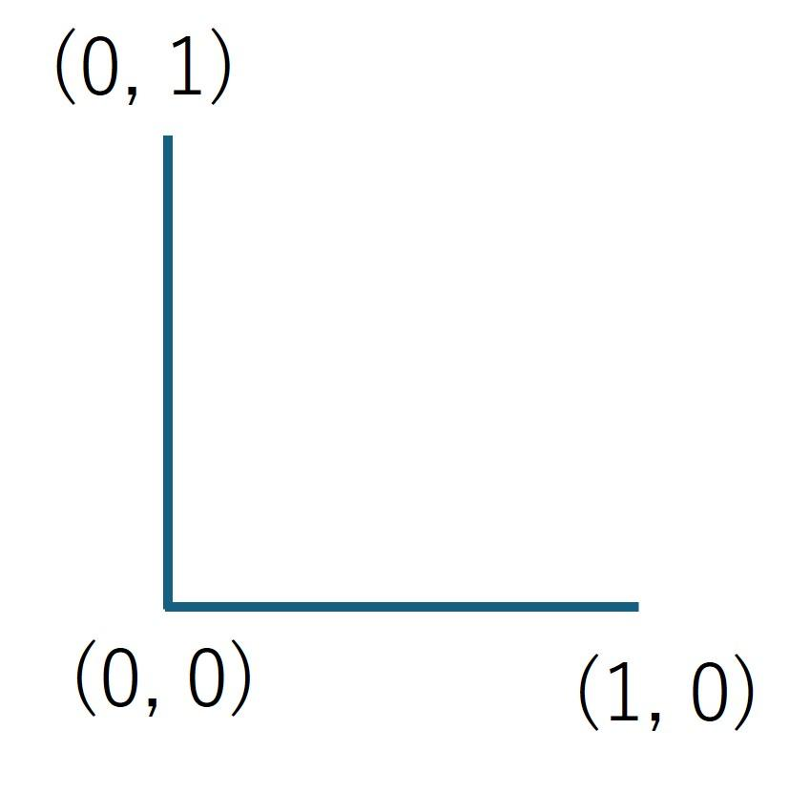
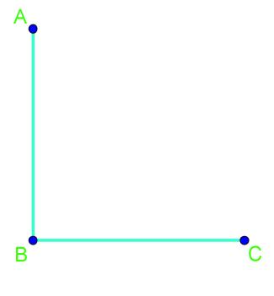
$$\boxed{θ={90}^{∘}}$$

3. Open Acute Two-Segment Shape
# Source: AI Source: Provided by: [Data Path: Persons Table -> ID Column: 1, Name_En Column: Motasem Essam] -> From: [ChatGPT] on [7/25/2026]
The two segments meet at an acute angle.
$$0^{∘}<θ<{90}^{∘}$$
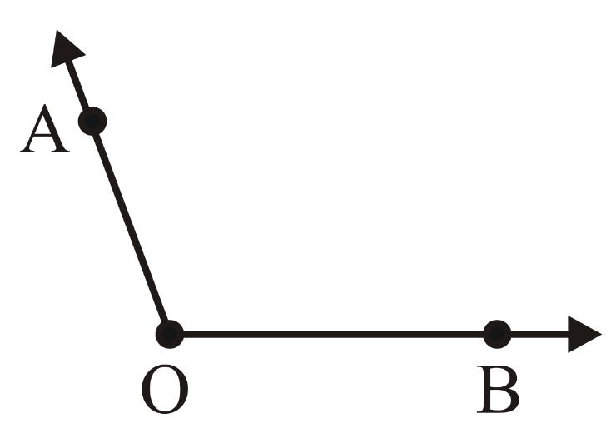

4. Open Obtuse Two-Segment Shape
# Source: AI Source: Provided by: [Data Path: Persons Table -> ID Column: 1, Name_En Column: Motasem Essam] -> From: [ChatGPT] on [7/25/2026]
The two segments meet at an obtuse angle.
$${90}^{∘}<θ<{180}^{∘}$$
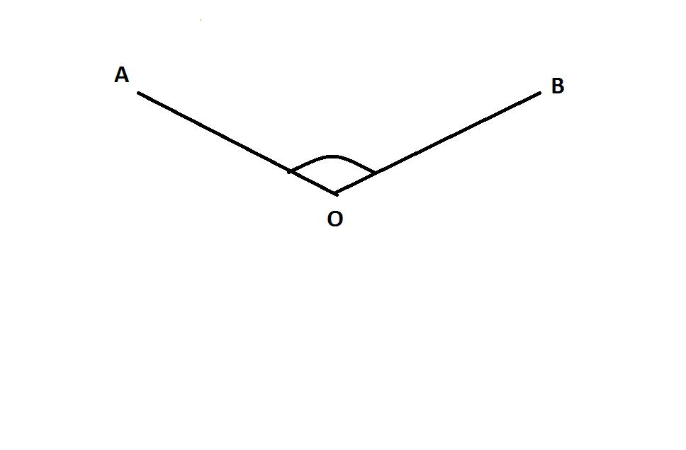
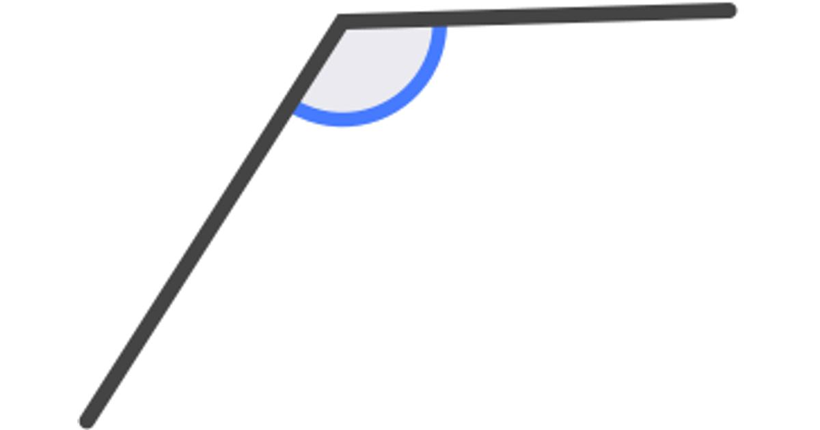

5. Open Straight Two-Segment Shape
# Source: AI Source: Provided by: [Data Path: Persons Table -> ID Column: 1, Name_En Column: Motasem Essam] -> From: [ChatGPT] on [7/25/2026]
The two segments are collinear and point in opposite directions from their common endpoint.
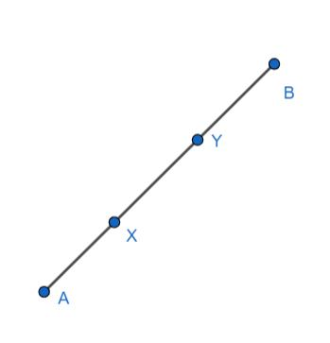
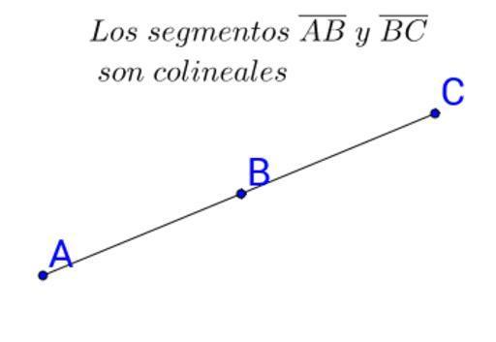
$$\boxed{θ={180}^{∘}}$$
Although it contains two segments, visually it forms one straight path.

6. Unequal Open Two-Segment Shape
# Source: AI Source: Provided by: [Data Path: Persons Table -> ID Column: 1, Name_En Column: Motasem Essam] -> From: [ChatGPT] on [7/25/2026]
The two segments have different lengths.
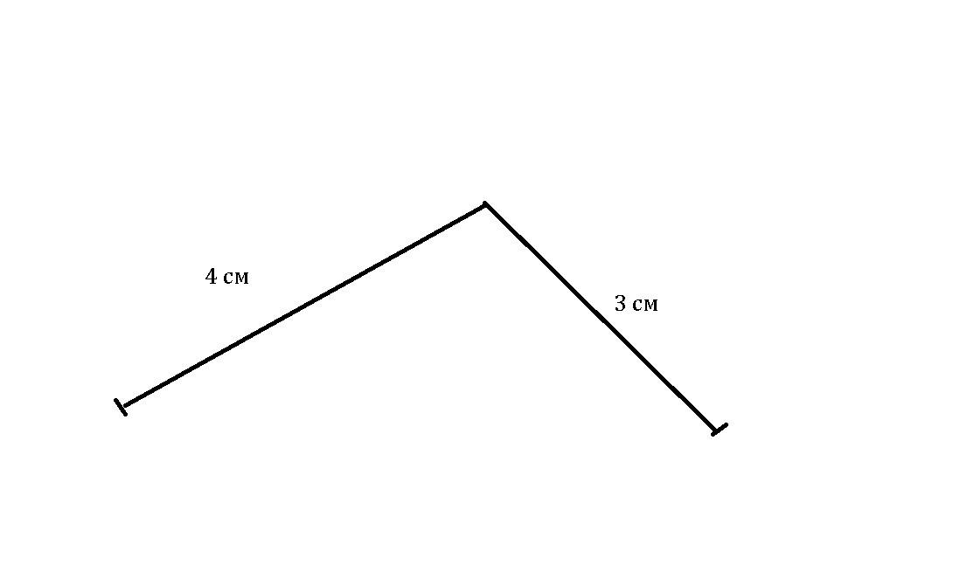
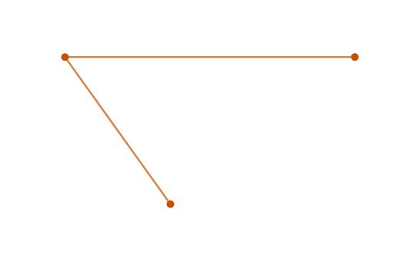
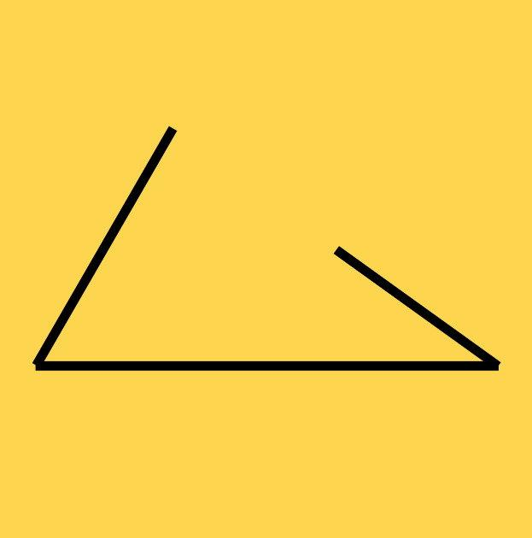
$$\boxed{L_{1}≠L_{2}}$$

7. Equal Open Two-Segment Shape
# Source: AI Source: Provided by: [Data Path: Persons Table -> ID Column: 1, Name_En Column: Motasem Essam] -> From: [ChatGPT] on [7/25/2026]
The two segments have equal lengths but remain open.
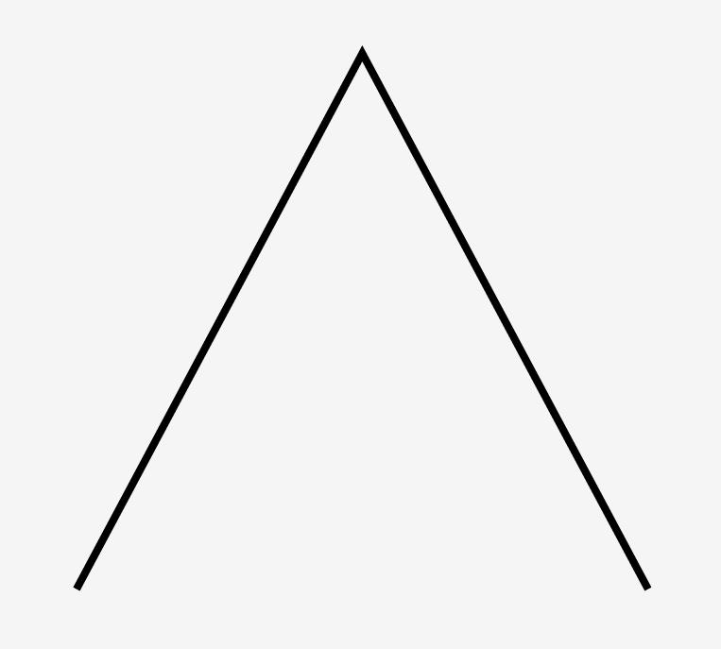
$$\boxed{L_{1}=L_{2}}$$
This shape can also have symmetry if the two segments are arranged symmetrically.

Classification by Angle
# Source: AI Source: Provided by: [Data Path: Persons Table -> ID Column: 1, Name_En Column: Motasem Essam] -> From: [ChatGPT] on [7/25/2026]
The same two-segment shape can be classified according to its vertex angle:
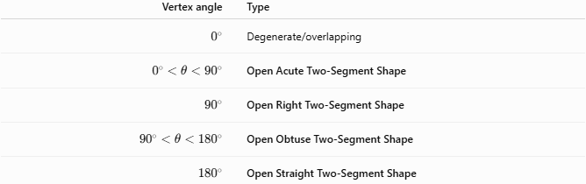
Vertex angle | Type
$$0^{∘}$$ | Degenerate/overlapping
$$0^{∘}<θ<{90}^{∘}$$ | Open Acute Two-Segment Shape
$${90}^{∘}$$ | Open Right Two-Segment Shape
$${90}^{∘}<θ<{180}^{∘}$$ | Open Obtuse Two-Segment Shape
$${180}^{∘}$$ | Open Straight Two-Segment Shape

Open Two-Segment Shape vs. Two-Sided Polygon
# Source: AI Source: Provided by: [Data Path: Persons Table -> ID Column: 1, Name_En Column: Motasem Essam] -> From: [ChatGPT] on [7/25/2026]
An important terminology point:
A two-segment open figure is not a polygon in the strict mathematical sense, because a polygon is normally a closed plane figure formed by line segments.
Therefore, for a mathematically precise classification system, I recommend naming it:
$$\boxed{\text{Open Two-Segment Polygonal Shape}}$$
rather than simply calling it a two-sided polygon.

Area and Perimeter
# Source: AI Source: Provided by: [Data Path: Persons Table -> ID Column: 1, Name_En Column: Motasem Essam] -> From: [ChatGPT] on [7/25/2026]
Area
Because the shape is open, it does not enclose a region:
$$\boxed{A\text{ is not defined as an enclosed area}}$$
Total Segment Length
Its total length can be calculated as:
$$\boxed{L=L_{1}+L_{2}}$$
where $L_{1}$ and $L_{2}$ are the lengths of the two segments.

Key Points
# Source: AI Source: Provided by: [Data Path: Persons Table -> ID Column: 1, Name_En Column: Motasem Essam] -> From: [ChatGPT] on [7/25/2026]
$$\boxed{\text{Open Two-Segment Polygonal Shape}2\text{ Connected Straight Segments}}$$
It has:
- Exactly 2 line segments.
- 3 endpoints/vertices.
- 1 common internal endpoint.
- 2 open endpoints.
- No enclosed area.
- No closed boundary.
- An angle between the two segments, except in the collinear case.

Conclusion
# Source: AI Source: Provided by: [Data Path: Persons Table -> ID Column: 1, Name_En Column: Motasem Essam] -> From: [ChatGPT] on [7/25/2026]
An Open Two-Segment Polygonal Shape is the simplest open polygonal path: it consists of exactly two straight segments joined at one common vertex, with the other two endpoints remaining unconnected.
$$\boxed{2\text{ segments}+1\text{ vertex}+2\text{ open endpoints}}$$
The most useful secondary classifications are based on the vertex angle (acute, right, obtuse, or straight) and on whether the two segments have equal or unequal lengths.

